Valeria Rocha 6thC
Webs
Web 1.0: it is the first stage of development on the World Wide Web that was characterized by simple static pages.
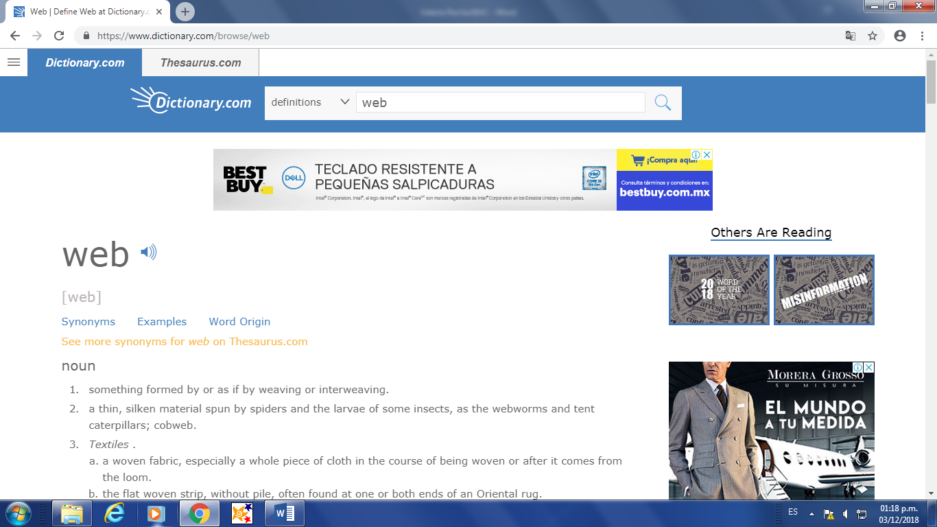

Web 2.0: it is the second generation of the World Wide Web with pages with more dynamic and interactive webs. 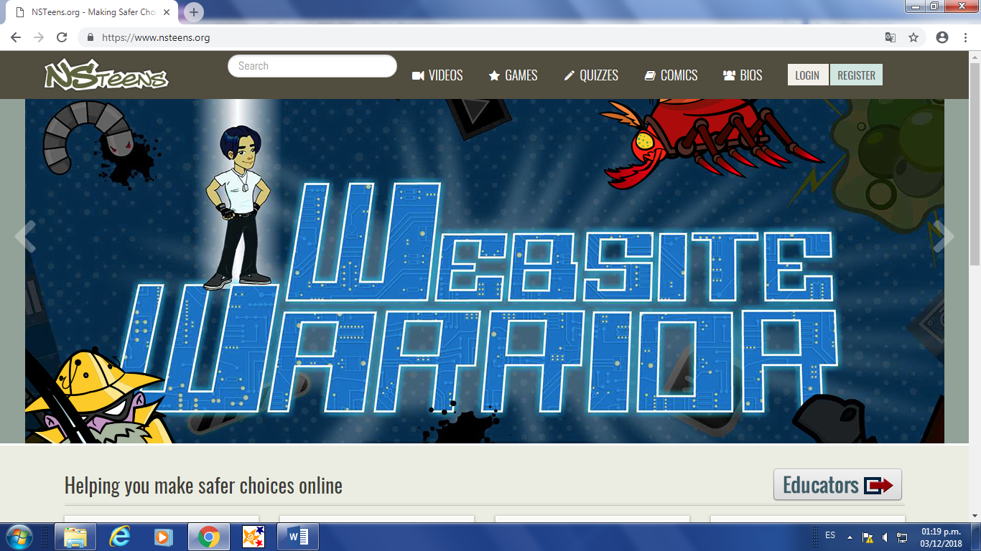
Web 3.0: it is a more interactives page and with smarter applications and the users can found exactly what they want. 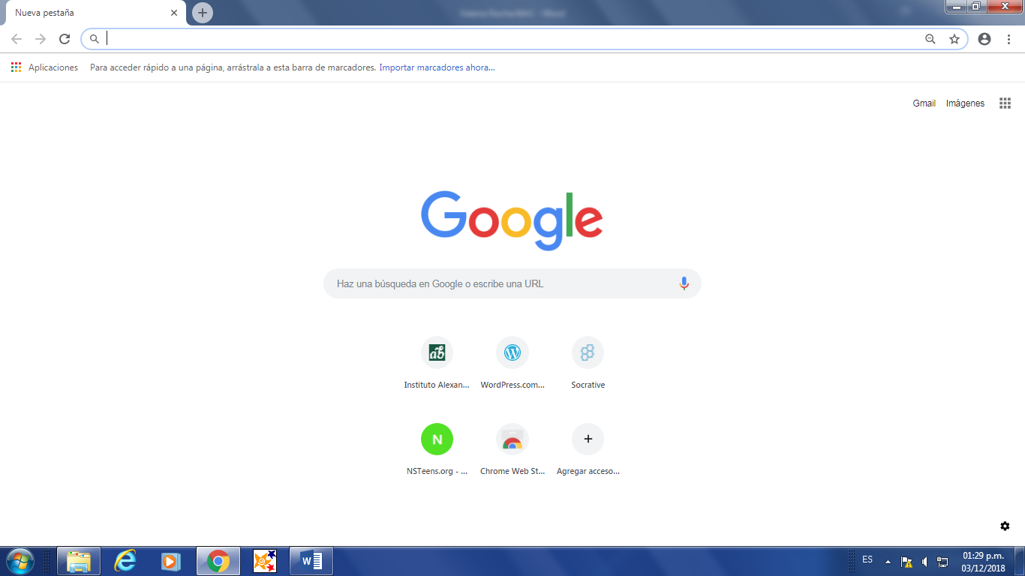

Web 4.0:it is almost starting but it is going to give all the good information and a complete and personalized interaction. 